St Timothy’s Episcopal Church
RenewalWorks Report
Annual Meeting
February 3, 2019
Slide 1: Renewal Works at St Tim’s

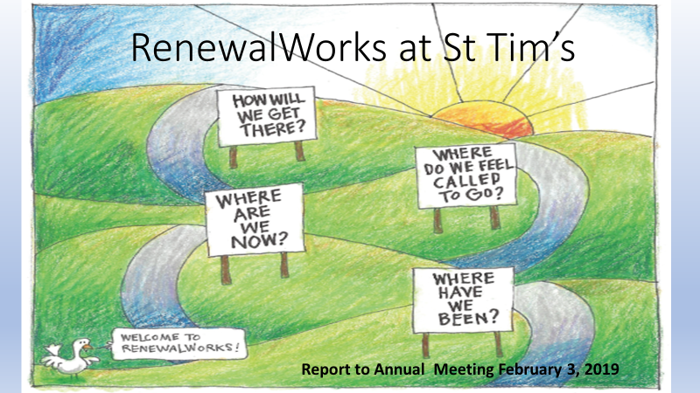

Good morning! I am Jennifer Saldanha from the RenewalWorks committee.
The odds are that all of you here today participated in the Spiritual Life Inventory, or survey last Fall. And the odds are even better that you think that it was like dropping a penny down a wishing well – pretty sure it reached the bottom but wonder about the point of the whole exercise, as there hasn’t even been an echo coming back from that penny.
The RenewalWorks committee has come here this morning to report on the results of that survey and to suggest some next steps for St Tim’s. I’ll be teaming with Dennis Haugh.

Slide 2: Our Involvement with RenewalWorks
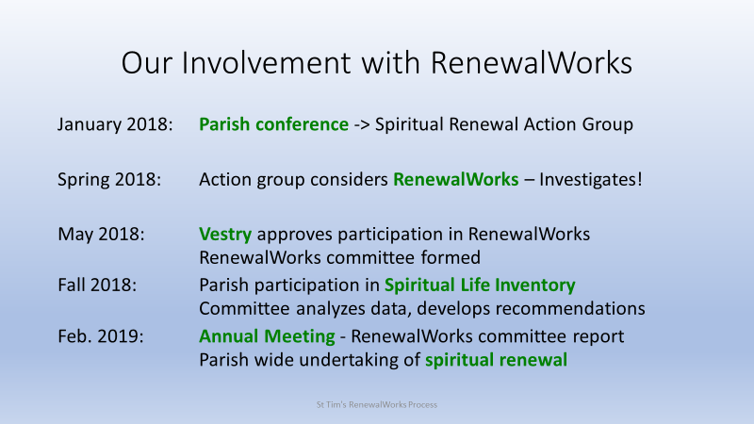

Let’s back up and review how St Tim’s became involved with RenewalWorks
It really all started with the formation of a Spiritual Renewal committee after last year’s parish conference.
That committee met several times and began to look at the possibility of engaging with RenewalWorks.
After doing our due diligence, the Spiritual renewal committee and the Vestry gave the go ahead to participate in RenewalWorks.
So, we formed a 14-member committee in Spring, to manage the Spiritual Life Inventory and understand the results. [???Name them; ask to rise to get acknowledged???]
Then in September the parish participated in the online Spiritual Life Inventory. The participation was amazing with 100% participation.
The RenewalWorks national team sent us a two-part report that has been linked to the RenewalWorks page on the parish website.
The St Tim’s committee has been working with the results of the survey and coming up with ideas for the continued spiritual growth of St. Tim’s. We are here this morning to summarize our conclusions.

Slide 3: What are We Talking About?

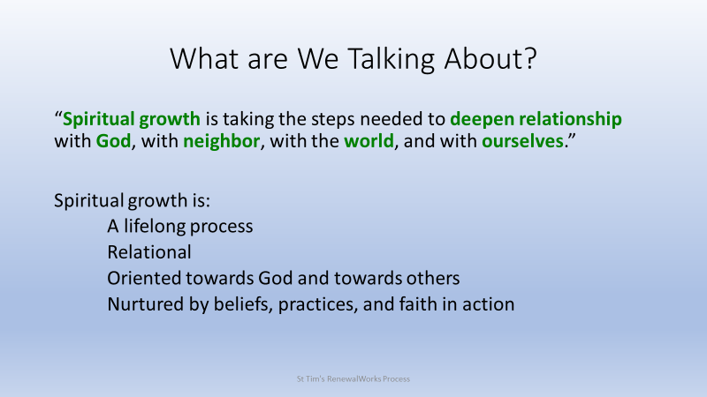
To start, it will be helpful to make sure we are all talking about the same thing. Spiritual life and spiritual growth mean different things to different people. For the sake of our discussion, we are using the RenewalWorks definition of spiritual growth, namely:
Spiritual growth is taking the steps needed to deepen relationship with God, with neighbor, with the world, and with ourselves.
We like this definition because it implies that spiritual growth is a process – it’s taking steps – and it is a process that goes on for our entire life.
Spiritual growth is a lifelong process because it is about deepening our relationships. Couples married for many years know well that they can continue to work on their relationship and find new ways to come together.
Now with whom are we building our relationships? In the Christian Episcopal tradition, we build our relationship with God and other people, with the natural world, and, as we do so, we come to understand and love ourselves more and more.
We experience spiritual growth as a consequence of many things – our beliefs, our practices, and how we put our faith into action.

Slide 4: Spiritual Growth Continuum

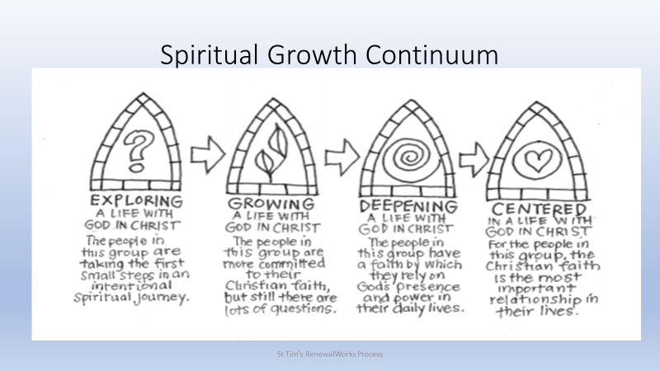
RenewalWorks has identified four stages in the spiritual life, shown on this slide as the “Spiritual Growth Continuum.” This is a very important concept and we will spend some time considering this continuum.
In the first stage, “Exploring a Life with God in Christ,” we are, as it were, thinking about what it means to be a disciple of Jesus Christ. We may be both comparing different religions – Buddhism, Christianity, Judaism, for instance – and different ways of being a Christian – Presbyterian, Methodist, Disciple of Christ perhaps.
In the second stage, “Growing a Life with God in Christ,” we have made some commitments – to Christ and to a particular way of being Christian. For us here today, for being Episcopalians. We come as community to affirm certain faith statements and follow certain practices. Like all good Episcopalians, of course we still have many questions about what all of this means.
In the third stage, “Deepening a Life with God in Christ,” we live with those questions, we accept the uncertainty they present in our lives, but we make a decision to live in reliance on God and God’s Word incarnated in Jesus Christ.
In the final stage, “Centered in a Life with God in Christ,” our life is fully informed by the development of relationships with God, our neighbors, our planet, and ourselves.
In this stage RenewalWorks claims that “the Christian faith is the most important relationship in their lives.” That is one of the first sticking points we and everyone else has with the continuum, because in our lives we claim that relationships with spouses and children are most important. I would simply assert that the great Christian insight is that God is love, so through loving relationships God enters our lives. Therefore, as we deepen our understanding of what it means to love a husband, or child, or wife, or neighbor we deepen our life with God.
Let me point out that just for purposes of illustration spiritual growth is shown as a straight-line process, progressing from one stage to the next. We know that it never ever happens that way.

Slide 5: Components of Episcopal Spiritual Vitality

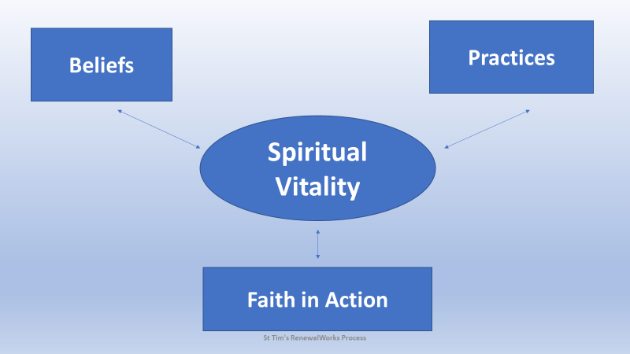
The RenewalWorks folks have identified three components of a spiritually vital life:
The first is our beliefs – what we profess each Sunday in the Nicene Creed, for instance. Not only do we admit the truth of those statements, do they have an impact in our life? Do we, for instance, believe in our bones that God is good and cares for each one of us?
Our beliefs are strengthened in our practices. How often do we join in Sunday worship? Is reflecting on the Bible part of our regular life? And those black books with the crosses on them in the pews – our Book of Common Prayer: can we even navigate through them?
Our beliefs and our practices lead us to faith in action. We recognize that that as Christ’s feet and hands in this world we are called to serve each other and the world around us.
To be frank, none of that seems like any major revelation: We know that a spiritually strong life has many components and they feed and support each other. We also know that each of us may be stronger in one area rather than another. It may vary from person to person and over time.

Slide 6: What’s Important to You?
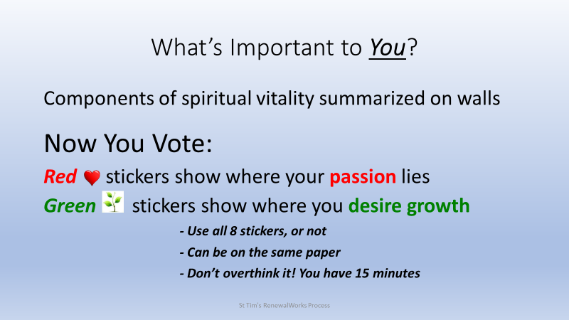
In light of that, we want to take a quick survey and get everybody up and moving.
When you came in, you received some red dots and some green dots, along with a list of components of spiritual vitality. Now you may notice that there are some posters stuck on the walls all around. Each poster represents one of the elements of spiritual vitality. We are giving you fifteen minutes to vote on those elements – first with red dots about those things that you are passionate about – perhaps you are passionate about reading the Bible or Sunday worship. Put a red dot next to those.
The green dots are for those areas where you would like to grow – perhaps a practice that you would like to adopt like regular Bible reflection or spending time figuring out why belief in the Trinity is important to Christians.
Now you have FOUR red and FOUR green dots. You can use them all or not.
Don’t overthink this exercise. Tomorrow or next month you may make different choices. We are looking for where you find yourself today.
START!

Dennis starts after the end of the exercise; Slide 6 stays up for a moment.
Thank you for your response to our exercise. We will be compiling the data and using it to open conversations at the RenewalWorks conference in three weeks.

The rest of our presentation will focus on the results of our spiritual life inventory with some of our recommendations about how to proceed.

Slide 7: Summary of St Tim’s Spiritual Vitality

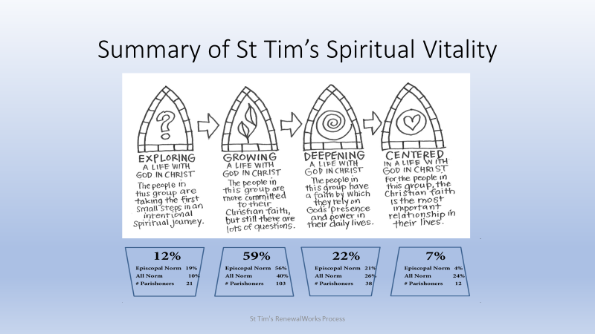

First of all, the national RenewalWorks staff analyzed our 175 responses to the Spiritual Life Inventory and summarized the results in this one picture. I want to repeat that links to the whole report as well as the parish committee’s take on it can be found on the RenewalWorks page on the parish website.
I’ll walk through this slide.
Up on top are the four stages of spiritual vitality we talked about earlier.
The percentages shown in the boxes below each stage show the results first for St Tim’s – the large numbers – then for the 200 Episcopal congregations surveyed, and then for the over 2000 congregations studied. The “Number of Parishioners” shows the number of us from St Tim’s in each category.
Aa majority, 59 percent, of St Tim’s adults are in the second category, “Growing a Life with God in Christ.” That’s slightly above the average of all Episcopalians, 56 percent, but well above the all parish norm of 40 percent. Of those surveyed, 103 are in this category.
I admit that I was surprised that a majority of St Tim’s adults are in this second stage of spiritual growth. It is a group who have a lot of questions about how to grow spiritually within the Episcopal tradition.
We are probably not surprised that St Tim’s results pretty well match the results for all Episcopalians.
Concluding that we have room for further spiritual growth is really not too surprising. What really made the committee think hard were the summary conclusions the RenewalWorks folk gave us.

Slide 8: RenewalWorks Conclusion about St Tim’s

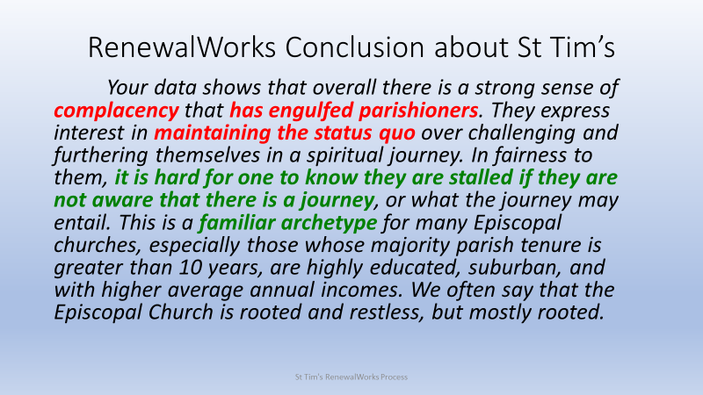

They summarized their analysis in this way:
Your data shows that overall there is a strong sense of complacency that has engulfed parishioners. They express interest in maintaining the status quo over challenging and furthering themselves in a spiritual journey. In fairness to them, it is hard for one to know they are stalled if they are not aware that there is a journey, or what the journey may entail. This is a familiar archetype for many Episcopal churches, especially those whose majority parish tenure is greater than 10 years, are highly educated, suburban, and with higher average annual incomes. We often say that the Episcopal Church is rooted and restless, but mostly rooted.
We didn’t appreciate being called complacent and we spent a lot of time thinking about what this really tells us.

Slide 9: Complacent? St Tim’s?
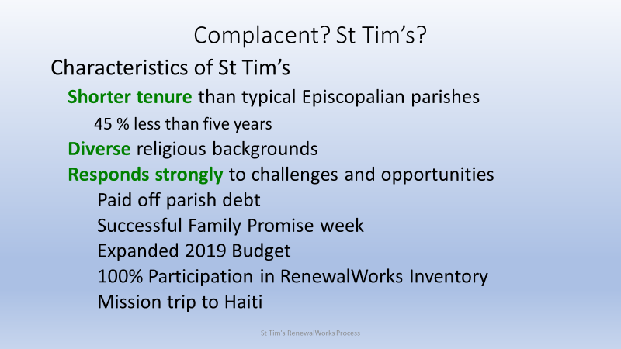
We started by looking closer at the characteristics of St Tim’s.
We noticed that compared with most Episcopalian parishes, we have spent less time at St Tim’s and as Episcopalians.
Along with that, we see that we come from many religious backgrounds – our committee for instance is composed of cradle Episcopalians along with those of us raised as Methodists and Presbyterians and Roman Catholics.
While RenewalWorks says we are “complacent” we have experienced a truly remarkable last twelve months.
St Tim’s has paid off the parish debt;
Even though we had a hugely successful debt campaign, we busted all expectations by also increasing our pledges to the operating budget, and now we are better supporting our staff and adding an associate priest;
Starting from scratch, we successfully hosted a Family Promise week and have three more coming up;
We had 100 percent participation in the RenewalWorks Spiritual Life Inventory;
And organized a mission trip to Haiti.
Does that seem like a year in the life of a complacent parish!

Slide 10: Complacent? St Tim’s?

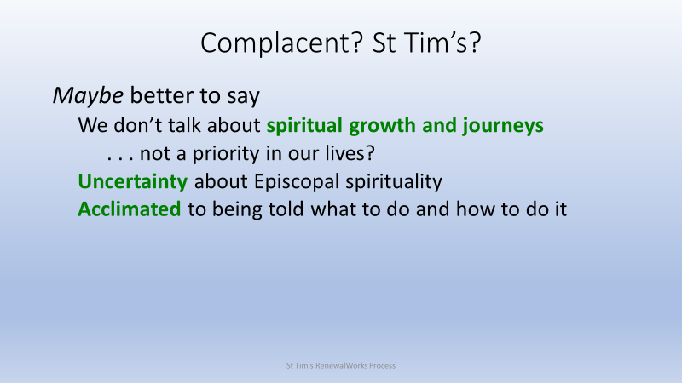
We suggest that rather than talking about complacency, perhaps we should be saying that as a parish we really don’t talk much about our spiritual growth and journeys. Perhaps they aren’t a priority in our lives.
We also looked at the data and detect a certain uncertainty about what it really means to be an Episcopalian. We are all attracted to the Episcopal Church and, especially, to the Episcopalians we know, but we still may struggle with Episcopal worship aerobics and finding our way through the Book of Common Prayer. We may be unsure about just how to grow in Episcopal spirituality.
And some of us come from religious traditions in which ministers, priests, and bishops told us what to do and how to do it. Fr. Nick’s practice of putting the burden on us to figure things out and explore new ideas is refreshing but can also be unnerving.
As a consequence, we don’t think St Tim’s is complacent in the usual sense of the term. but we do think that the conclusion we are mostly in the earlier stages of spiritual growth may be accurate.
And that led to wonder: What can we do about it? How can we help each other grow spiritually?

Slide 11: Best Practices Summary

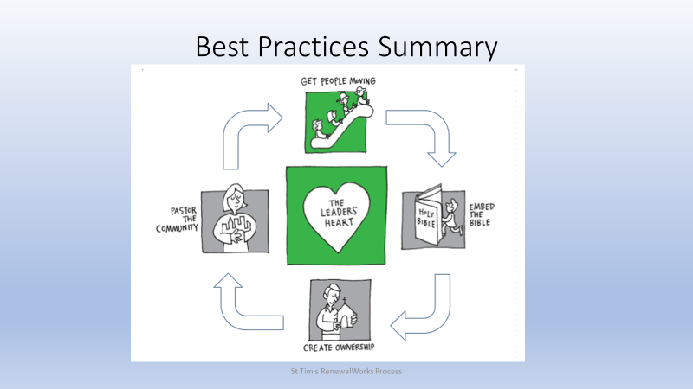
Based on their work with hundreds of congregations, the national RenewalWorks team has identified five areas of best practices that help parishes move forward spiritually. On this slide, the two areas in which St Tim’s is strong are colored green and the three areas where we have opportunities for growth are in gray.
According to RenewalWorks, the Heart of the Leader is the key to a parish’s spiritual growth, so it’s shown in the middle of the diagram. The “leader” includes all of the rector, staff, vestry, committee heads, and so forth. Together, they must single-mindedly champion spiritual growth as the priority for the parish.
With the Heart of the Leader goes “Getting People Moving.” St Tim’s is good at communicating to everyone that we are on a spiritual journey and fostering a vital, dynamic community.
As a committee, we decided to focus our attention on the other three practices, those shown in gray.
To Pastor the Community is to deepen our relationship with Jesus through a commitment to service, in the church and in the neighborhood. A big part is learning what God is already doing, by listening to neighborhood voices, including voices from other religious traditions, and working for justice and peace wherever the needs surface.
When we Embed the Bible, in the life of the parish we move people in each stage of the spiritual continuum. This is cited as the single most transformational practice for spiritual growth.
When we Create Ownership, each member enjoys both the freedom and responsibility to pursue spiritual growth. While parish leaders set expectations for spiritual growth, we are expected to take responsibility for growing in relationship with God, our neighbors and ourselves, through spiritual practices and service.

Slide 12: Examples of Best Practice
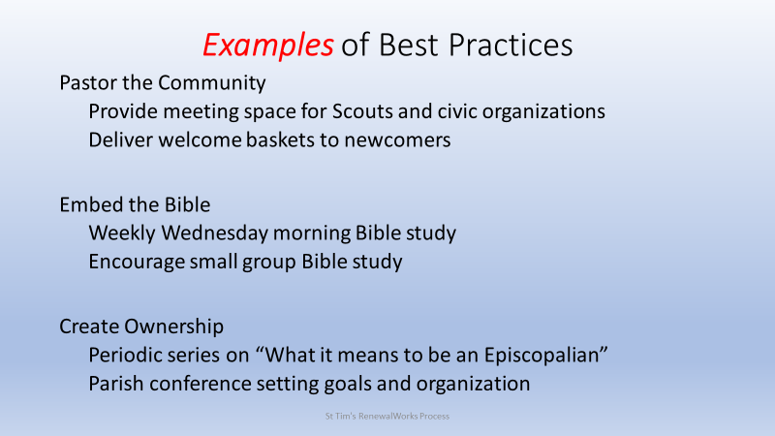
We spent time imagining how to make those three practices a reality in the life of St Tim’s, and on this slide we set out some of those ideas.
St Tim’s is already involved with the surrounding community, doing such things as providing space for local Scouting troops and civic organizations. Perhaps we could extend our efforts by delivering welcome baskets to those moving into the neighborhood, introducing ourselves and the services available.
To embed the Bible more deeply in our life, we might organize Bible study groups throughout the parish. As a start, Fr. Nick has committed to leading a weekly Bible study on Wednesday mornings. Perhaps we could start other groups relying on the expertise of other parishioners.
When you come down to it, calling us “complacent,” really amounts to a challenge to take ownership of our own spiritual development. As we have such diverse backgrounds, we think that periodically offering a series on “What it means to be an Episcopalian” can help all of us grasp the riches of our tradition.
Many of our successes of the past twelve months had their beginnings in last year’s parish conference. The conference brought together the whole parish to select goals for the year and organize whatever needed organizing to reach them. We KNOW from that experience that the parish responds well when ideas and goals really reflect the desires and strengths of St Tim’s. Those are best identified and communicated when the whole parish joins together.

Slide 13: Our Proposed Next Step
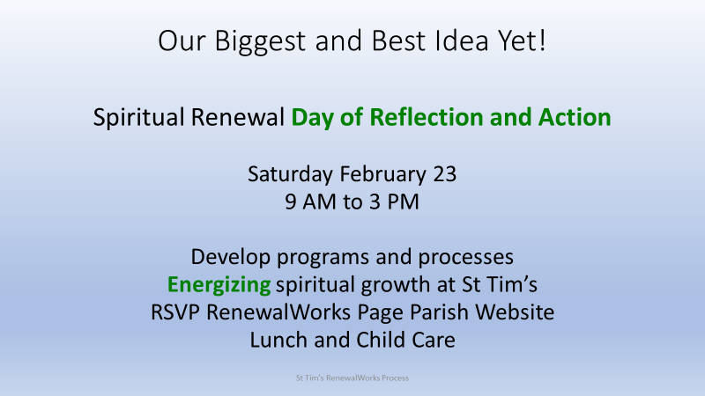
So we are proposing that the parish come together on Saturday February 23 for a day of Reflection and Action. We will be looking at the areas where you have a passion and where we all want to go further . . . those red and green dots on the posters. Together, we will explore your ideas for raising the spiritual energy level at St Tim’s going forward. We will be planning how to embed the Bible, pastor our communities, and create ownership of our spiritual lives.
Because we will be serving lunch and offering child care, we would appreciate knowing how many are coming and any special needs. Completing the form on the RenewalWorks page of the parish website would be most helpful.
We hope that all of you will decide to come, because when all of us are involved shaping St Tim’s future, the successes of the past twelve months show we succeed. Every single time. For sure, we have what it takes to set St Tim’s on the road to further adventures. Let’s do this!

